**Predicting and Optimizing Biopolymer Adoption:**

**A Machine Learning Approach to Reducing Plastic Dependency**

NIH Notes

* There is a growing need for eco-friendly packaging, specifically in the food packaging industry
* It is projected that a 50% increase in global food supplies will be needed by 2050
* Packaging materials need to maintain food quality while also meeting demands of consumers, producers and legislative forces

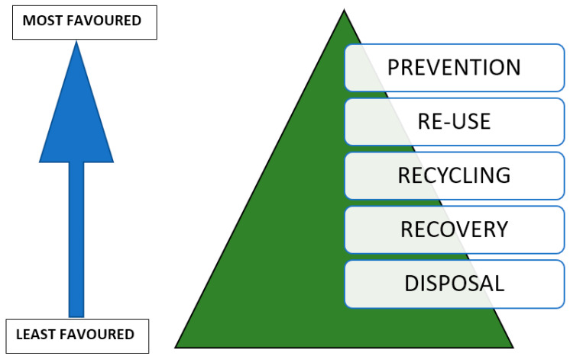

**Hierarchy of Waste Treatment**

* Packaging used today is dominated by fossil-fuel plastics
* Three types of green packaging have been identified
  + Reusable packaging, e.g., glass which can be reused after cleaning.
  + Recyclable packaging, e.g., paper which can be reprocessed and reused.
  + Biodegradable packaging, e.g., cotton sacks which can break down into the environment without causing damage.
* Food packaging industry is now in pursuit of biodegradable packaging
* **Biodegradation** is a process of defragmentation, initiated by heat, moisture, and/or microbial enzymes, which transforms longer molecular substances into smaller compounds
* **Biopolymers** are produced by living organisms or derived from biomass and are completely biodegradable
  + Can be thermosetting or thermoplastic
* Widespread use of biopolymers is no longer an action, but a necessity
  + Can lead to reduced plastic waste
  + Lower greenhouse gas emissions
  + Guarantees sustainable exploitation of environmental resources

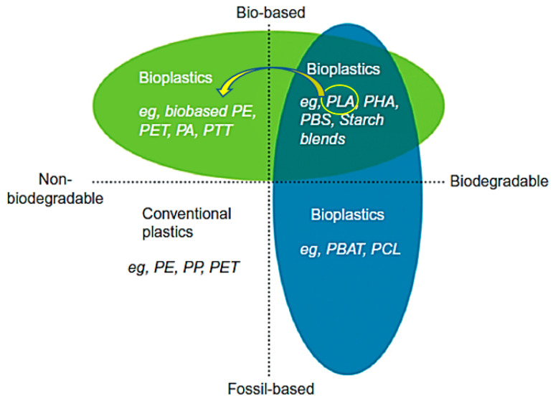

**Types of Plastics by Common Names**

Types of Biopolymers

**PLA (polylactic acid)**

**PHA (polyhydroxyalkanoates)**

**PBS (Polybutylene succinate)**

**Starch blends**

**PVA (Polyvinyl Alcohol)**

**PEG (Polyethylene Glycol)**

Resources

***Environmental Impact of Food Packaging Materials: A Review of Contemporary Development from Conventional Plastics to Polylactic Acid Based Materials***

<https://www.ncbi.nlm.nih.gov/pmc/articles/PMC7664184/#B14-materials-13-04994>

***The Next Generation of Sustainable Food Packaging to Preserve Our Environment in a Circular Economy Context***

<https://www.frontiersin.org/journals/nutrition/articles/10.3389/fnut.2018.00121/full>

***Biopolymers as packaging material in food and allied industries***

<https://scholar.google.com/scholar_lookup?journal=IJCS&title=Biopolymers+as+packaging+material+in+food+and+allied+industry&author=A.+Yadav&author=S.+Mangaraj&author=R.+Singh&author=N.+Kumar&author=S.+Arora&volume=6&publication_year=2018&pages=2411-2418&>

***Where is the Value in the Chain? Pathways out of Plastic Pollution***

<https://documents1.worldbank.org/curated/en/099100004052240464/pdf/P17086905776c404087850cf73c75f371f.pdf>

***Biodegradable and compostable alternatives to conventional plastics***

<https://www.ncbi.nlm.nih.gov/pmc/articles/PMC2873018/>

***Biodegradable plastics and polymers***

<https://www.canr.msu.edu/news/real-time-science-biodegradable-plastics-and-polymers>

***PlastChem Project Database (Plastic Chemicals & Polymers)***

<https://plastchem-project.org/>

**1. Define the Problem Statement**

• **Objective**: To use machine learning algorithms to rank biopolymers as potential substitutes for food packaging to reduce reliance on traditional, fossil-fuel based plastics.

• **Key Questions**:

• What sectors (e.g., packaging, automotive, consumer goods) can benefit most from biopolymer integration?

• What are the challenges in adopting biopolymers (e.g., cost, performance, supply chain issues)?

• How can we predict the success of biopolymer products in different markets?

**2. Data Collection**

• **Biopolymer Properties**: Gather data on various biopolymers, including their physical, chemical, and mechanical properties.

• **Traditional Plastic Properties**: Gather data on currently used plastics, including their physical, chemical, and mechanical properties.

• **Market Data**: Collect data on market trends, consumer preferences, and adoption rates of biopolymers in different industries.

• **Environmental Impact**: Include data on the environmental impact of biopolymers compared to traditional plastics.

• **Cost Analysis**: Gather data on the production costs of biopolymers and traditional plastics, including raw material costs and supply chain considerations.

**3. Data Preprocessing**

• **Cleaning**: Handle missing values, remove duplicates, and ensure data quality.

• **Normalization/Standardization**: Normalize the data to ensure that all features contribute equally to the model.

• **Feature Engineering**: Create new features that could help improve model performance, such as combining related features or calculating environmental impact scores.

**4. Exploratory Data Analysis (EDA)**

• **Market Segmentation**: Use clustering techniques to identify which market segments are most likely to adopt biopolymers.

• **Trend Analysis**: Analyze trends over time to understand how biopolymer adoption is evolving.

• **Correlation Analysis**: Identify relationships between biopolymer properties, costs, and market success.

**5. Model Selection**

• **Classification Models**: Use classification models to predict which markets are most likely to adopt biopolymers.

• **Regression Models**: Implement regression models to predict the potential market share of biopolymers in various sectors.

• **Optimization Algorithms**: Use optimization techniques (e.g., linear programming, genetic algorithms) to suggest optimal strategies for biopolymer integration, balancing cost, performance, and environmental impact.

**6. Model Training and Evaluation**

• **Train the Model**: Split your data into training and test sets. Train your model using the training set.

• **Evaluate the Model**: Use metrics such as accuracy, precision, recall, F1 score, and RMSE (Root Mean Square Error) to evaluate your model’s performance.

• **Hyperparameter Tuning**: Optimize the model’s hyperparameters using techniques like Grid Search or Random Search to improve performance.

**7. Results Interpretation and Optimization**

• **Interpret the Results**: Analyze which factors most influence the success of biopolymer integration.

• **Suggest Strategies**: Based on the model’s predictions, propose strategies for different industries to integrate biopolymers effectively.

• **Sensitivity Analysis**: Perform sensitivity analysis to understand how changes in key parameters (e.g., cost, supply chain efficiency) impact biopolymer adoption.

**8. Deployment**

• **Web Application**: Develop a web application that allows users to input parameters (e.g., industry, market size, biopolymer type) and receive recommendations for biopolymer integration.

• **API Integration**: Offer an API for companies to integrate the predictive model into their existing systems.

• **Visualization**: Include interactive visualizations to help stakeholders understand the model’s recommendations.

**9. Project Documentation**

• **Write a Detailed Report**: Document your entire process, from data collection to model deployment, including the challenges faced and how they were overcome.

• **Code Repository**: Create a well-organized code repository on GitHub or another platform, with clear instructions on how to use and deploy the model.

• **“Predicting and Optimizing Biopolymer Adoption: A Machine Learning Approach to Reducing Plastic Dependency”**

**11. Potential Impact**

• **Business Impact**: Help companies identify the best markets for biopolymer products, reducing costs and increasing market share.

• **Environmental Impact**: Contribute to reducing plastic waste and promoting sustainable materials.

This project will be highly relevant to industries looking to transition to sustainable materials and could have significant environmental and economic benefits.

### 

## Problem Statement

**Objective**

To use machine learning algorithms to rank biopolymers as potential substitutes for food packaging to reduce reliance on traditional, fossil-fuel based plastics.

Environment model outputs an “Environment Score”

Cost model outputs a “Cost Score”

Properties model outputs a “Properties Score”

**Key Topics to Address**

* What sectors (e.g., packaging, automotive, consumer goods) can benefit most from biopolymer integration?
* What are the challenges in adopting biopolymers (e.g., cost, performance, supply chain issues)?
* How can we predict the success of biopolymer products in different markets?